Technology Stack

The technology stack defines the tools, frameworks, and platforms used for system implementation.
4.1 Data Collection Layer
- Sensors (Current, Voltage, Temperature)
- IoT interfaces (optional)
4.2 Backend and Processing
- Python for data processing
- Pandas and NumPy for analysis
- Scikit-learn for ML models
4.3 Machine Learning Models
- Linear Regression
- Random Forest Regressor
- Support Vector Regression
- Neural Networks (optional)
4.4 Database
- CSV / SQL Database
- Cloud storage (optional)
4.5 Visualization and Interface
- Matplotlib / Seaborn
- Web dashboard (optional using Flask or Streamlit)

4.6 Deployment
- Local system or cloud environment
- Version control using Git
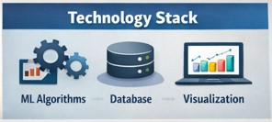

Conclusion of Requirement Analysis
The Requirement Analysis phase ensures that the Motor Temperature Prediction system is well-defined, user-centric, and technically feasible. By mapping the customer journey, defining data flow, specifying solution requirements, and selecting an appropriate technology stack, the project is prepared for the design and implementation phases.

